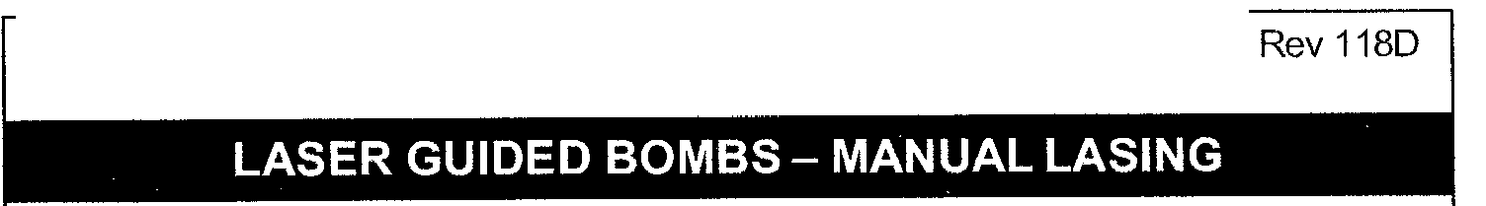
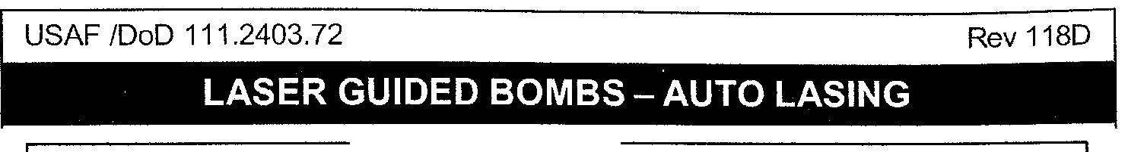
USAF /DoD 111.2403.72
For a LGB release, you need the following MFD slots:
TGP- SMS -FLIR -FCR in your MFD SLOTS config
~
In Manual LASING, the pilot has to fire the LASER manually. This is done by holding down the trigger detent.
The laser fire is confirmed by the flashing L in the FLIR MFD. If Manual LASING was started- the AUTO LASING is overridden. Manual LASING needs to be performed until weapon impact.
1. Master ARM 2. Master Mode 3. MFD Slot 4. SMS
5. LASER ARM
6. AG RADAR Mode 7. AG RADAR
8. MFD
9. FUR
10. Weapon CUE 11. Active LASING
12. .LASER ARM 13. Master ARM
F-16C/DBL52
SET ARM
SET A-G
Check Correct
Select GBU to be released (note station number) SET ARM
SET As Required Designate Target
Select TGP Slot
Slew and LOCK target in POINT
Pickle and HOLD (CCRP)
Active Lase Target until impact with First trigger detent.
Confirm LASING with flashing L SAFE (after impact)
SET SAFE
4/12

Note:
AUTO lasing mode will lase target after bomb release according
to the Laser Timer set in the LASER OED page. If you set 10 sec in the LASER Timer the LASER will fire 10 seconds BEFORE bomb Impact. When the LASER fire, a flashing L is displaved on the FLIR MFD.
1. Master ARM
2. Master Mode
3. MFD Slot
4. SMS
5. LASER ARM 6. LASER TIMER
SET ARM
SET A-G
Check Correct
Select GBU to be released (note station number) SET ARM
Check Timer ACTIVE
7. AG RADAR Mode SET As Required
8. AG RADAR Designate Target
9. MFD Select TGP Slot
10. FUR
11. Weapon CUE
12. Weapon in flight
13. LASER ARM 14. Master ARM
Slew and LOCK target in POINT
Pickle and HOLD (CCRP) till bomb release
Check that L starts flashing as soon as the impact timer meets the Laser timer value.
SAFE (after impact)
SET SAFE
~ DO NOT modify any settings after bomb release or the AUTO LASING will not work!
F-16 C/D BL52
5/12

